**Ref. No. MES IMCC / 198/ 2024 – 25 Date:27/12/2024**

**CERTIFICATE**

This is to certify that the Project entitled **“Loan Check**“ is completed by **“Pratyush Prakash Majumdar**” of M.C.A. Semester I for the Academic Year 2024-25 at MES’ Institute of Management & Career Courses (IMCC), Pune - 411038.

To the best of our knowledge, this is an original study done by the said student and important sources used by him/her have been duly acknowledged in this report.

The report is submitted as a part of course ITP11 Mini Project for the Academic Year 2024-25 as per the rules and guidelines prescribed by the institute.

  

Ms. Kalpana Dhende Ms. Manasi Shirurkar Dr. Ravikant Zirmite

Project Coordinator Program Coordinator Head, Dept. Of MCA

**Ref. No. MES IMCC / 198/ 2024 – 25 Date:27/12/2024**

**CERTIFICATE**

This is to certify that the Project entitled **“Loan Check**“ is completed by **“Aditya Mahesh Pattar**” of M.C.A. Semester I for the Academic Year 2024-25 at MES’ Institute of Management & Career Courses (IMCC), Pune - 411038.

To the best of our knowledge, this is an original study done by the said student and important sources used by him/her have been duly acknowledged in this report.

The report is submitted as a part of course ITP11 Mini Project for the Academic Year 2024-25 as per the rules and guidelines prescribed by the institute.

  

Ms. Kalpana Dhende Ms. Manasi Shirurkar Dr. Ravikant Zirmite

Project Coordinator Program Coordinator Head, Dept. Of MCA

**Synopsis**

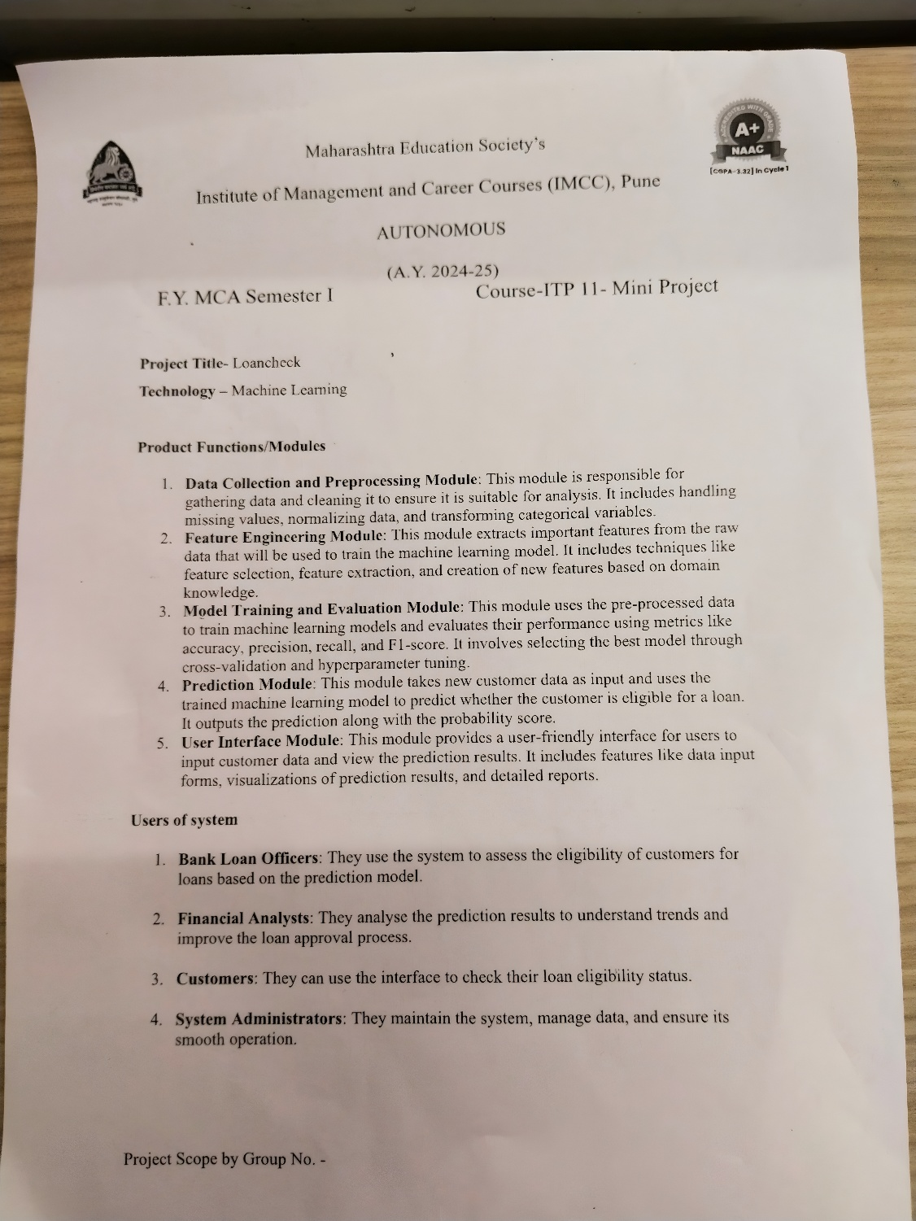

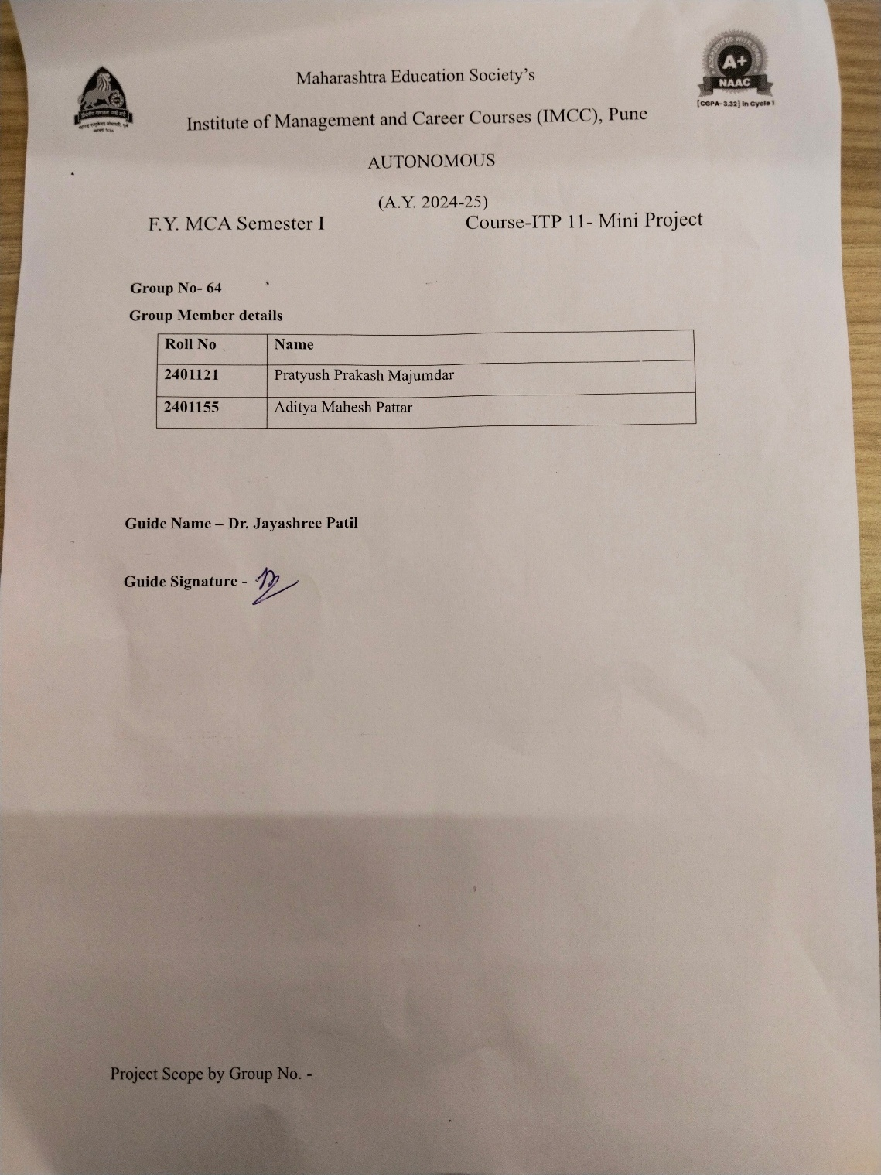

**Use Case Diagram**

Input from user

Classification model

Train data

Test data

Apply ML algorithm

Flask output

**Snapshots**

1. Prediction Page

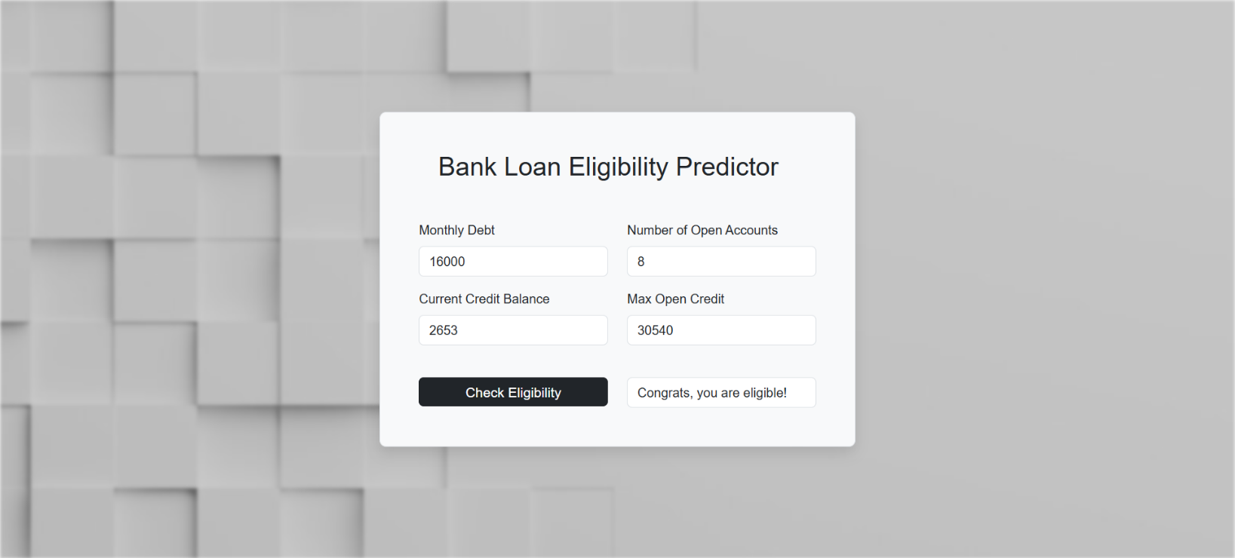

1. Import libraries and read the dataset

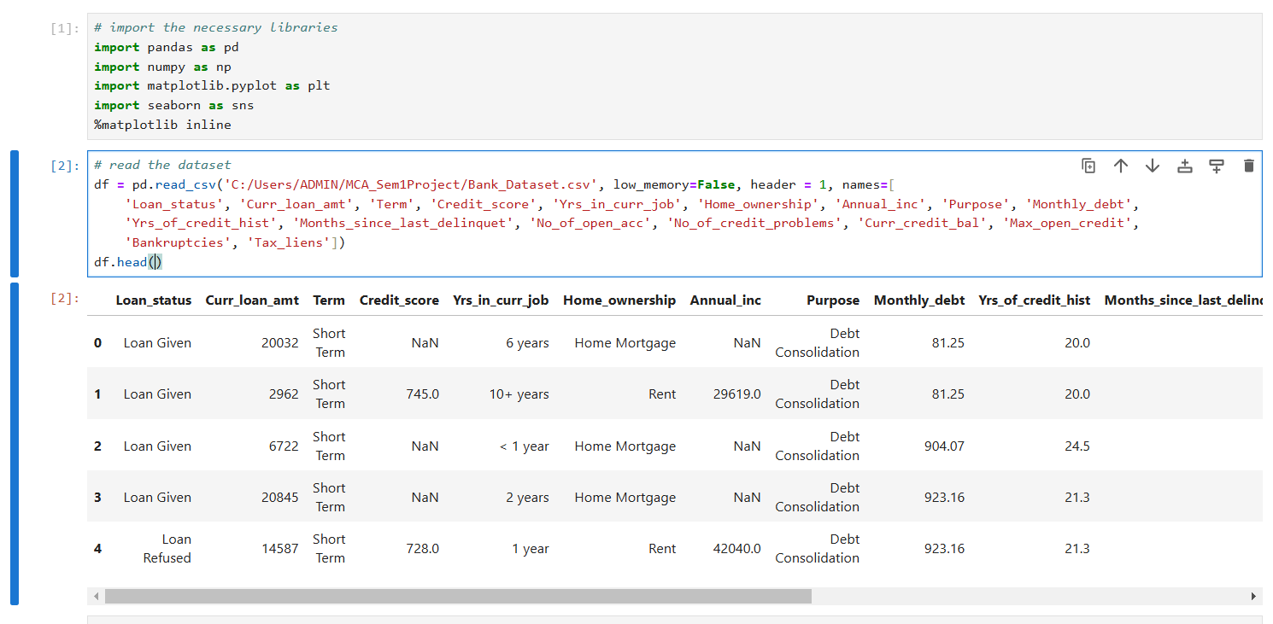

3) Check info and duplicate values

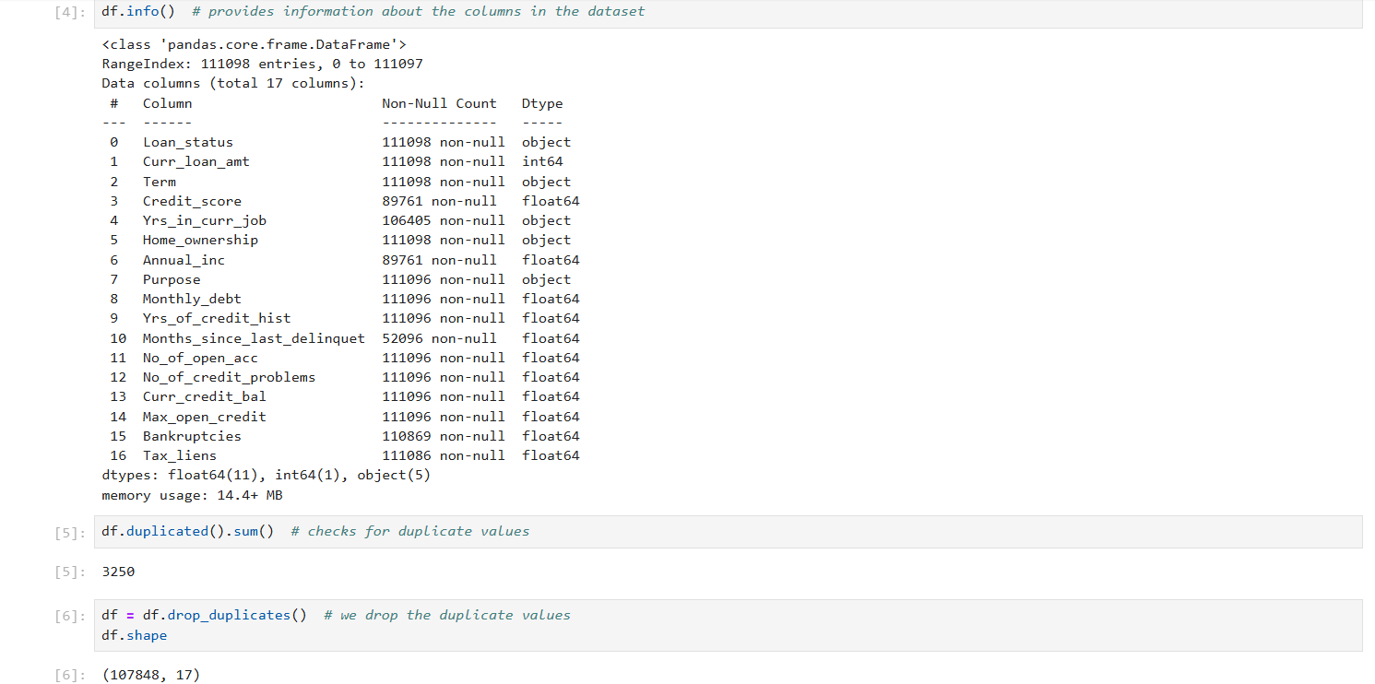

4) Check and replace null values

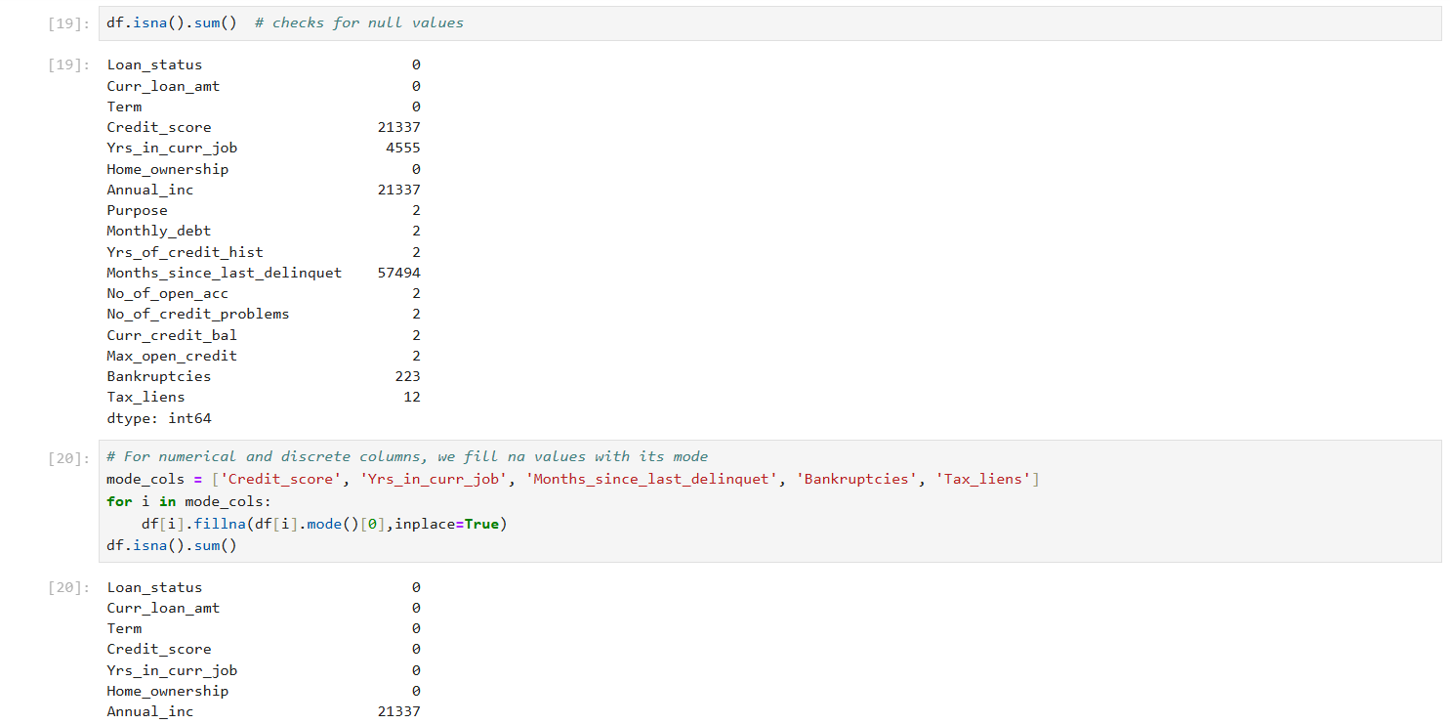

1. Create histograms to check skewness of data

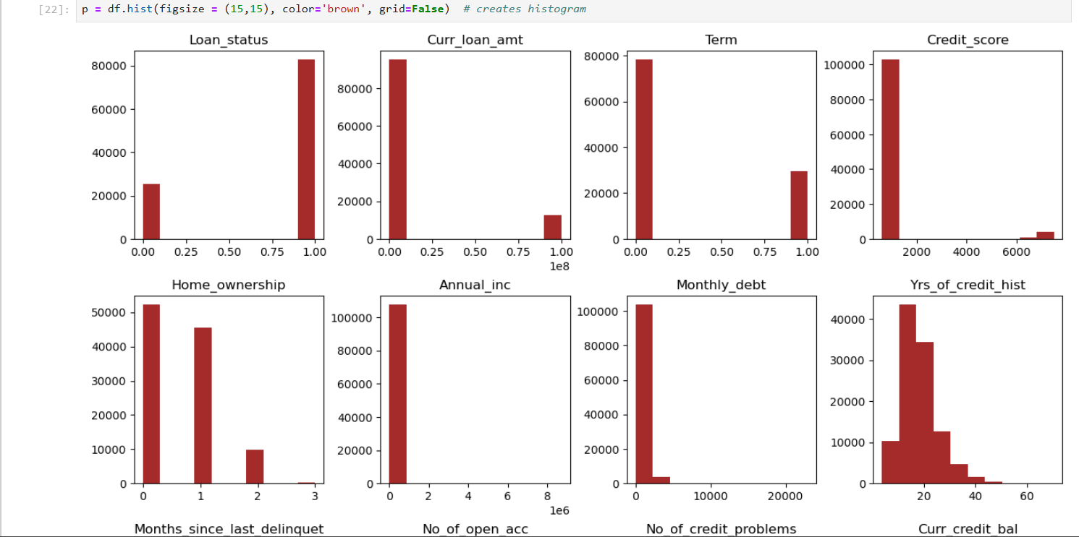

1. Check and handle outliers

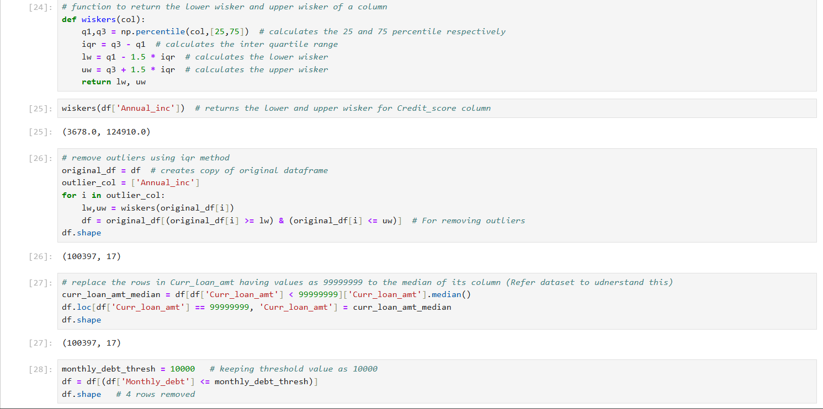

1. 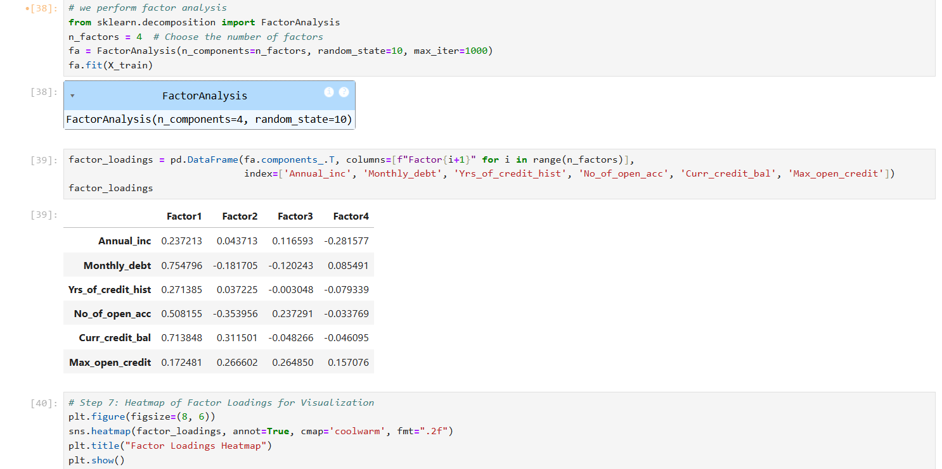Perform factor analysis to find potential factors
2. Heatmap to display the factor loadings

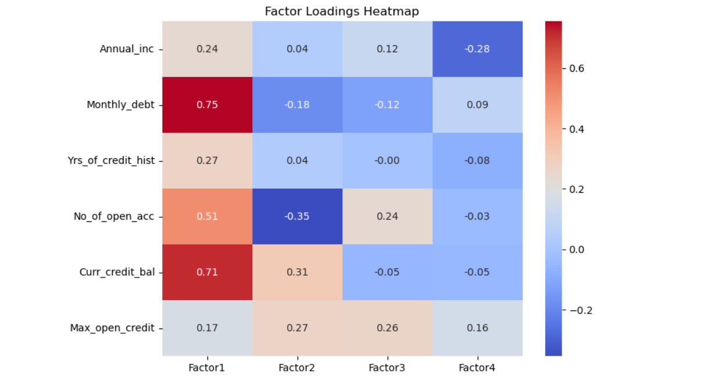

9) Find the best model for prediction

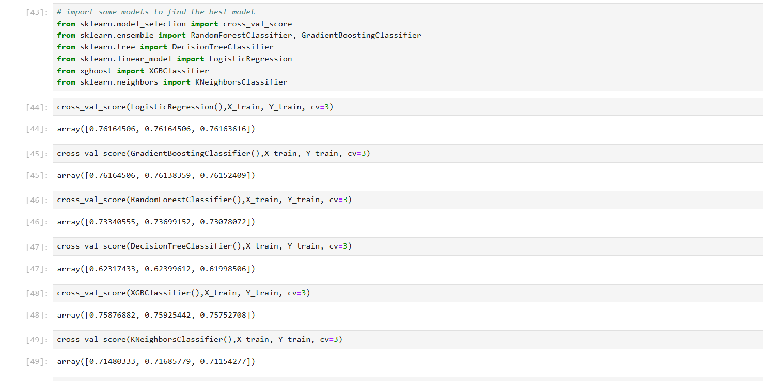

10) Calculate metrics.

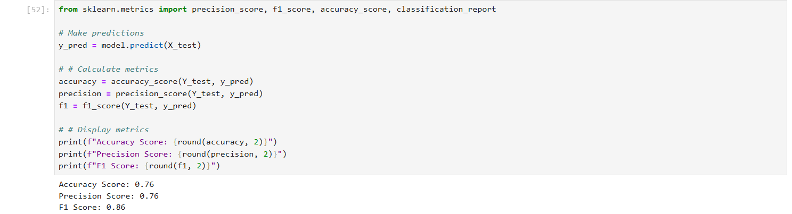

11) Store predictions in excel and pickle file

